**Internship Report on**

**Building intranet site for tracking issues**

**Oil and Natural Gas Corporation Ltd.,**

**Chennai**

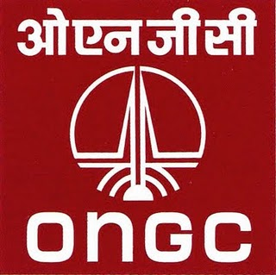

**by**

GAYATHRI E (CB.EN.U4CSE17420)

**ACKNOWLEDGEMENT**

I take this opportunity to thank **Shri GVR Kumar, I/C** **Processing Center**, Oil & Natural Gas Corporation, Chennai for providing me a project as a part of my training program in their organization.

I would like to thank **Shri Somesh Ranjan, ED-Head SDC and Shri V.R.Ganeshun, GM(P), SDC,** ONGC, Chennai, & **P Nandakumaran, DGM(P),** providing me with this opportunity.

I would like to extend my sincere gratitude to my mentor **Ms. S.Manjula DGM (Prog.),** and special thanks to **Mr. B. Ravinder Nath, GM (Prog.), Mr Pruthvee, Programming officer** for their constant guidance, advice and motivation throughout the training phase.

I would like to thank my **CSE HOD Dept. Amrita School of Engineering Coimbatore,** **Dr. (Col.) P. N. Kumar** for the constant encouragement and support they gave to the students to take up innovative projects and training courses.

**INTRODUCTION**

**Oil and Natural Gas Corporation Limited** (**ONGC**) ([NSE](https://en.wikipedia.org/wiki/National_Stock_Exchange_of_India): ONGC, [BSE](https://en.wikipedia.org/wiki/Bombay_Stock_Exchange): [500312](http://www.bseindia.com/bseplus/StockReach/AdvanceStockReach.aspx?scripcode=500312))

It is an Indian [multinational](https://en.wikipedia.org/wiki/Multinational_corporation) [oil](https://en.wikipedia.org/wiki/Petroleum) and [gas](https://en.wikipedia.org/wiki/Natural_gas) company headquartered in [Dehradun, India](https://en.wikipedia.org/wiki/Dehradun,_India). It is one of the largest Asia-based oil and gas exploration and production companies, and produces around 72% of India's [crude oil](https://en.wikipedia.org/wiki/Petroleum) (equivalent to around 30% of the country's total demand) and around 48% of its [natural gas](https://en.wikipedia.org/wiki/Natural_gas). It is one of the largest publicly traded companies by [market capitalization](https://en.wikipedia.org/wiki/Market_capitalization) in India. ONGC has been ranked 357th in the [Fortune Global 500](https://en.wikipedia.org/wiki/Fortune_Global_500) list of the world's biggest corporations for the year 2012. It is also among the Top 250 Global Energy Company by [Platts](https://en.wikipedia.org/wiki/Platts).

ONGC was founded on 14 August 1956 by the Indian state, which currently holds a 69.23% equity stake. It is involved in exploring for and exploiting hydrocarbons in 26 sedimentary basins of India, and owns and operates over 11,000 kilometers of pipelines in the country. Its international subsidiary ONGC Videsh currently has projects in 15 countries. ONGC has discovered 6 of the 7 commercially-producing Indian Basins, in the last 50 years, adding over 7.1 billion tonnes of In-place Oil & Gas volume of hydrocarbons in Indian basins. Against a global decline of production from matured fields, ONGC has maintained production from its brownfields like Mumbai High, with the help of aggressive investments in various IOR (Improved Oil Recovery) and EOR (Enhanced Oil Recovery) schemes. . Recovery Factor has improved from 28 per cent [in 2000] to 33.5 per cent (in 2011). Significantly Reserve Replenishment Ratio for the last 7 years, has been more than one.

**History of RCC, Chennai**

Established in 1987 with the aim to cater the needs of seismic data processing for **Krishna-Godavari** and **Cauvery basins**.

Started with ND-570 system having processing capacity of 1.2 MSR per annum. Currently equipped with IBM PC cluster System, HP PC Cluster and IBM P690 System for Basic Seismic Data processing in Time domain and Depth domain and Sun workstations for Seismic Data Archiving.

**Core Activities**

2D & 3D seismic data Processing in Time and Depth domain, VSP data processing and special processing such as AVO & Seismic Inversion Data archival and transcription from round tapes to high density media.

**Description of the Project**

Issue Tracker System developed here is an intranet site used for the purpose of requesting a solution for an issue faced by any user in RCC, find/view/check solutions to the issues.

The system after receiving solutions for the issue, will be displayed on the user’s profile who got the issue for the confirmation. The solution can either be accepted or denied by the user, which decides the status where the particular issue is closed or active.

**Target users**

RCC Users

**Initial Functional Requirements**

* Collection of information about employees and save it in database.
* Proper retrieval mechanism(e.g. when cpf number and password is entered ,all the details regarding that have to be retrieved)

**Software Requirements**

## 

## Technologies used

PHP,SQL,HTML,CSS :

**PHP** (Hypertext Preprocessor) is a general-purpose programming language originally designed for web development.

**XAMPP** is a free and open-source cross-platform web server solution stack package developed by Apache Friends, consisting mainly of the Apache HTTP Server, MariaDB database, and interpreters for scripts written in the PHP and Perl programming languages.

**HTML**, HyperText Markup Language, gives content structure and meaning by defining that content as, for example, headings, paragraphs, or images. **CSS**, or Cascading Style Sheets, is a presentation language created to style the appearance of content—using, for example, fonts or colors.

**SQL** is a standard computer language for relational database management and data manipulation.

Tools & Development Environment:

* XAMPP
* MySQL SERVER

**Back End Database:** MySQL

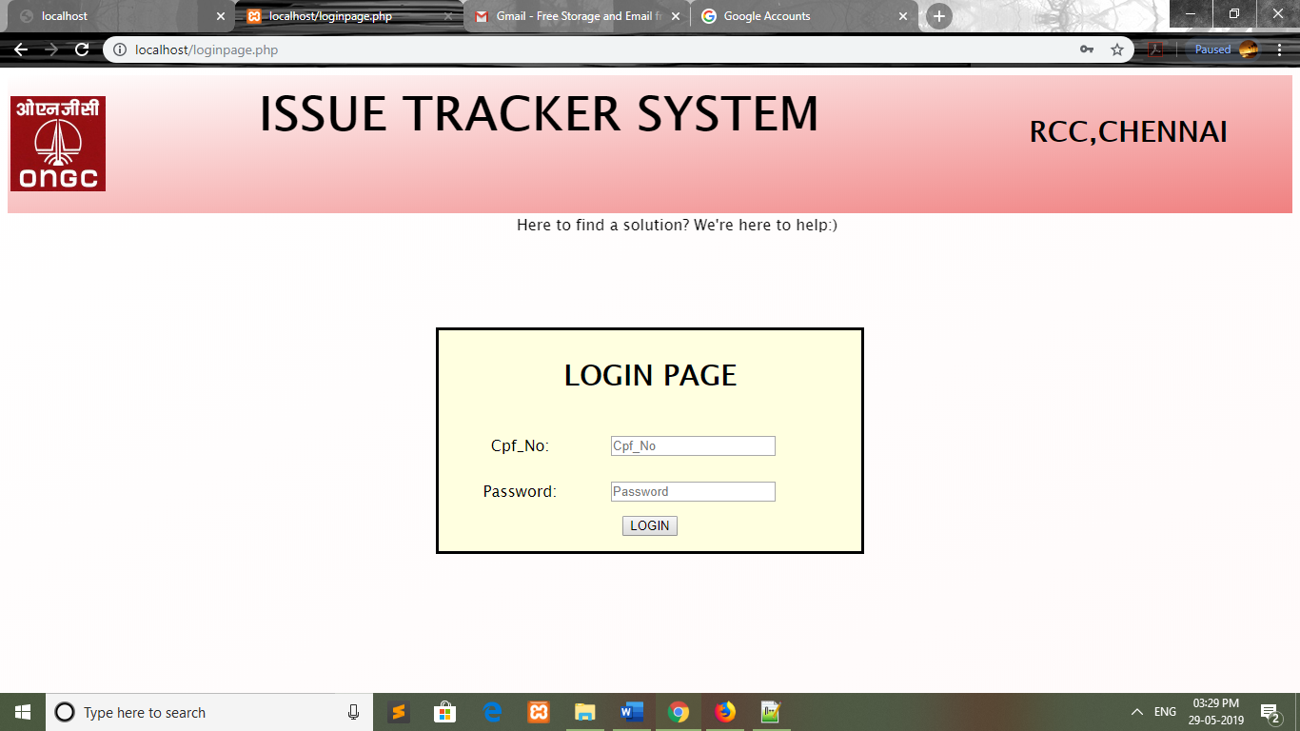

Pagename: loginpage

Fields:Cpf_No,Password

Table: login

Process: Logs in to your profile.

Error: no

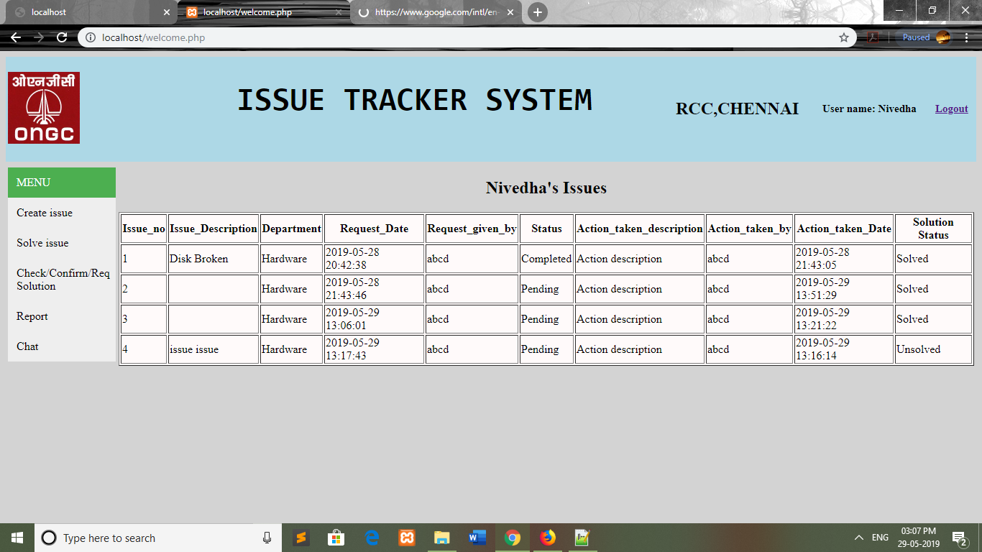

Pagename: welcome

Fields:menu : Create issue,Solve issue,Check/Confirm/Req solution,Report ,Chat

Table:issues

Process: Displays issues you’ve submitted and the status of it.

Error: no

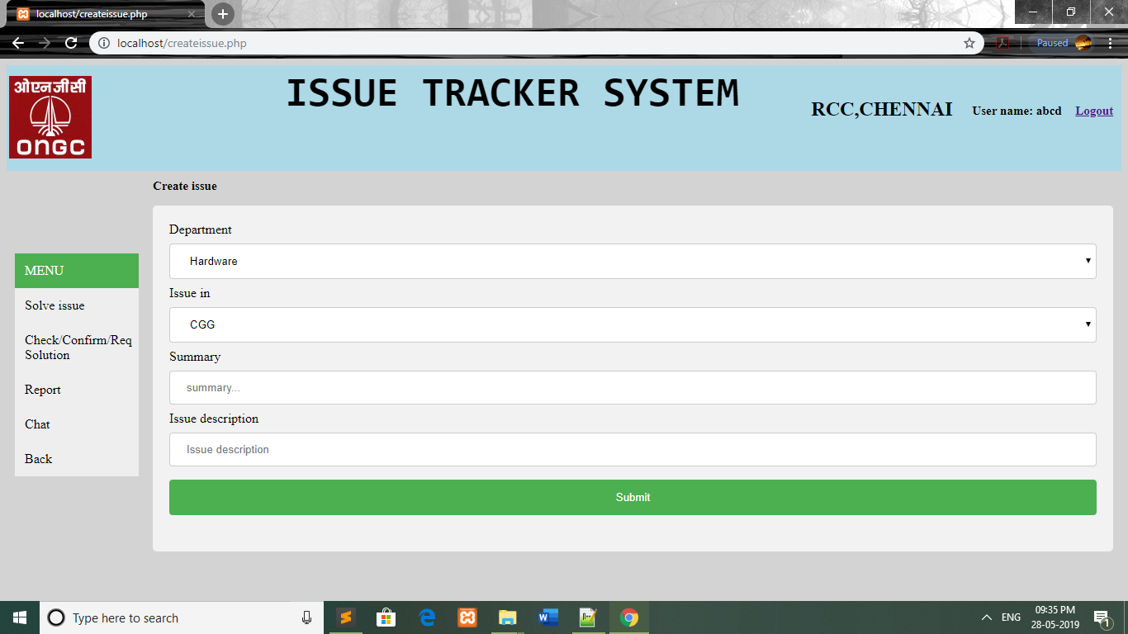

Pagename: createissue

Fields:Department,Issue in,Summary,Issue Descritption

Table:issues

Process: Collects the issue and stores it in the database and goes back to the updated “your issues” table in the welcome page.

Error: no

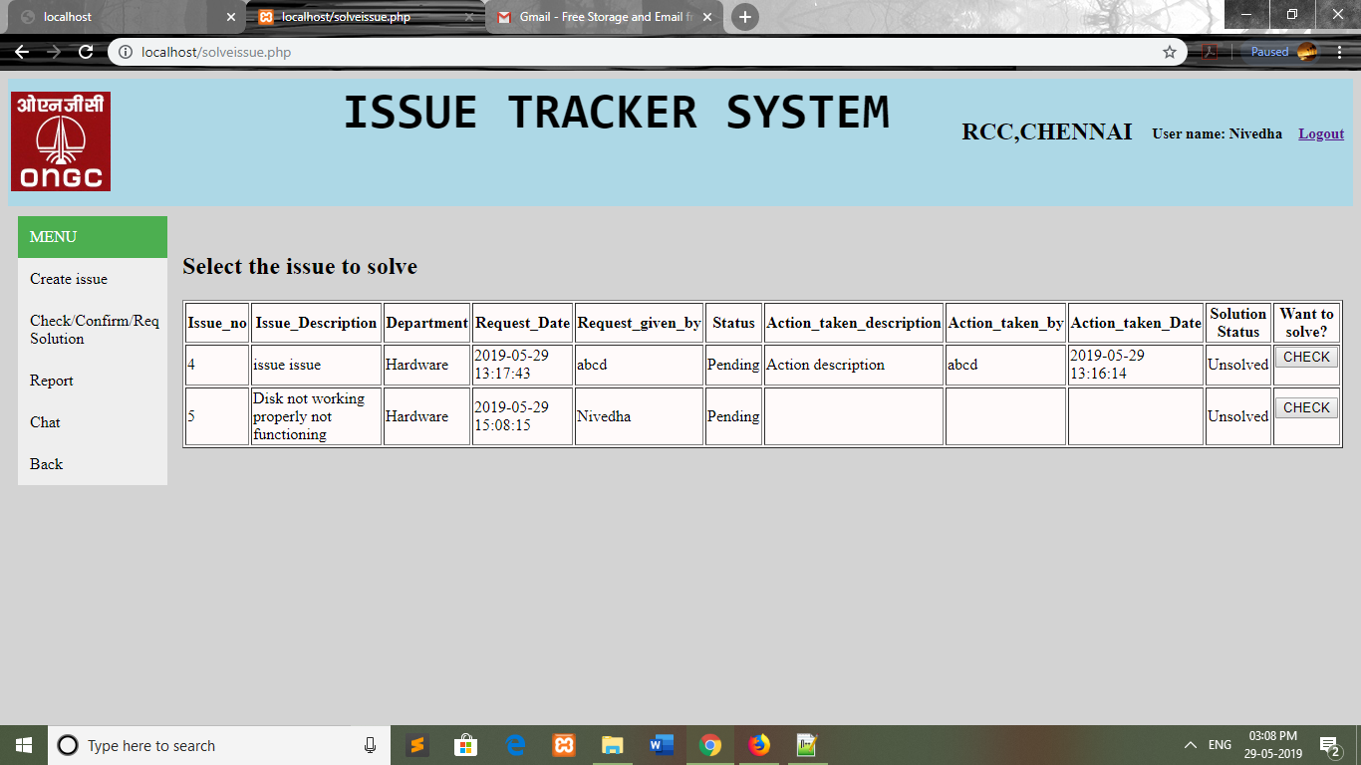

Pagename: Check/Confirm/Req Solution

Fields:Issue ID,Issue Description, Status

Table:issues

Process: Let’s user to solve any issue in his department .

Error: no

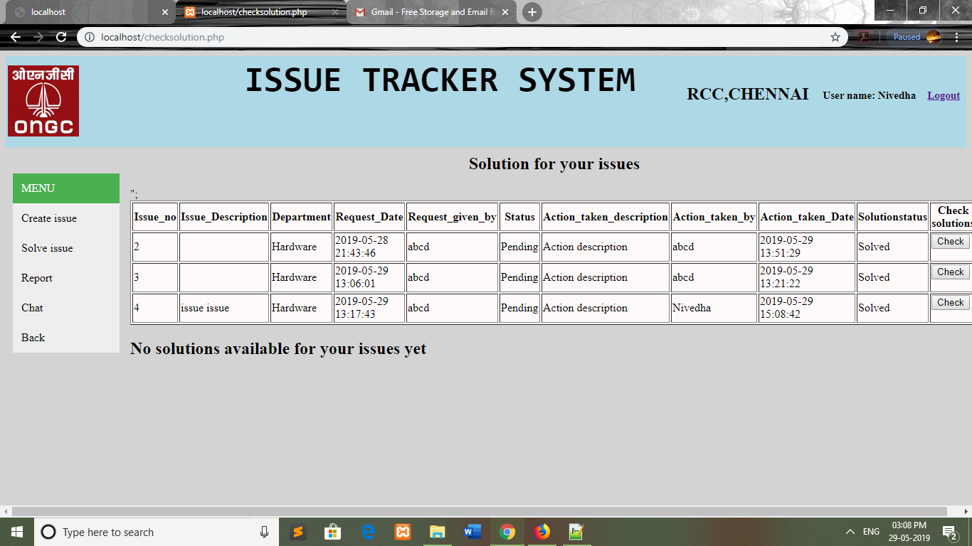

Pagename: checksolve

Fields: Menu : Create issue,Solve issue,Check/Confirm/Req solution

Table:issues

Process: Displays the already existing solutions to the issue and let’s the user solve.

Error: no

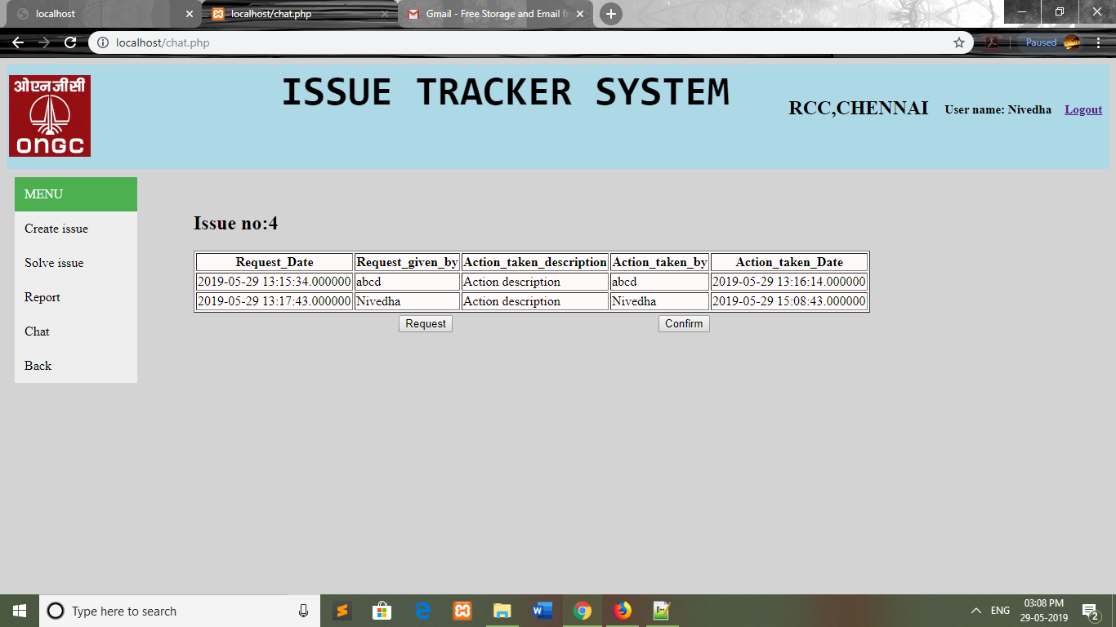

Pagename: checksolve

Fields: Menu : Create issue,Solve issue,Check/Confirm/Req solution

Table:issues

Process: Displays the already existing solutions to the issue and let’s the user to confirm or request solution again

Error: no

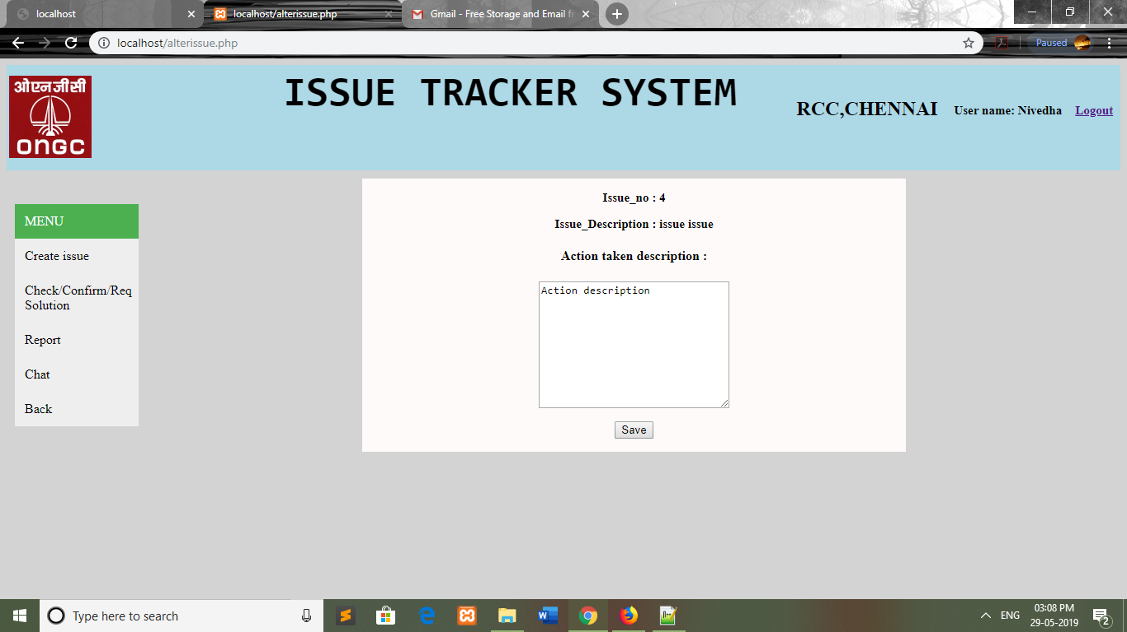

Pagename: alterissue

Fields:menu : Create issue,Solve issue

Table:issues

Process: Allows user to write the solution.

Error: no

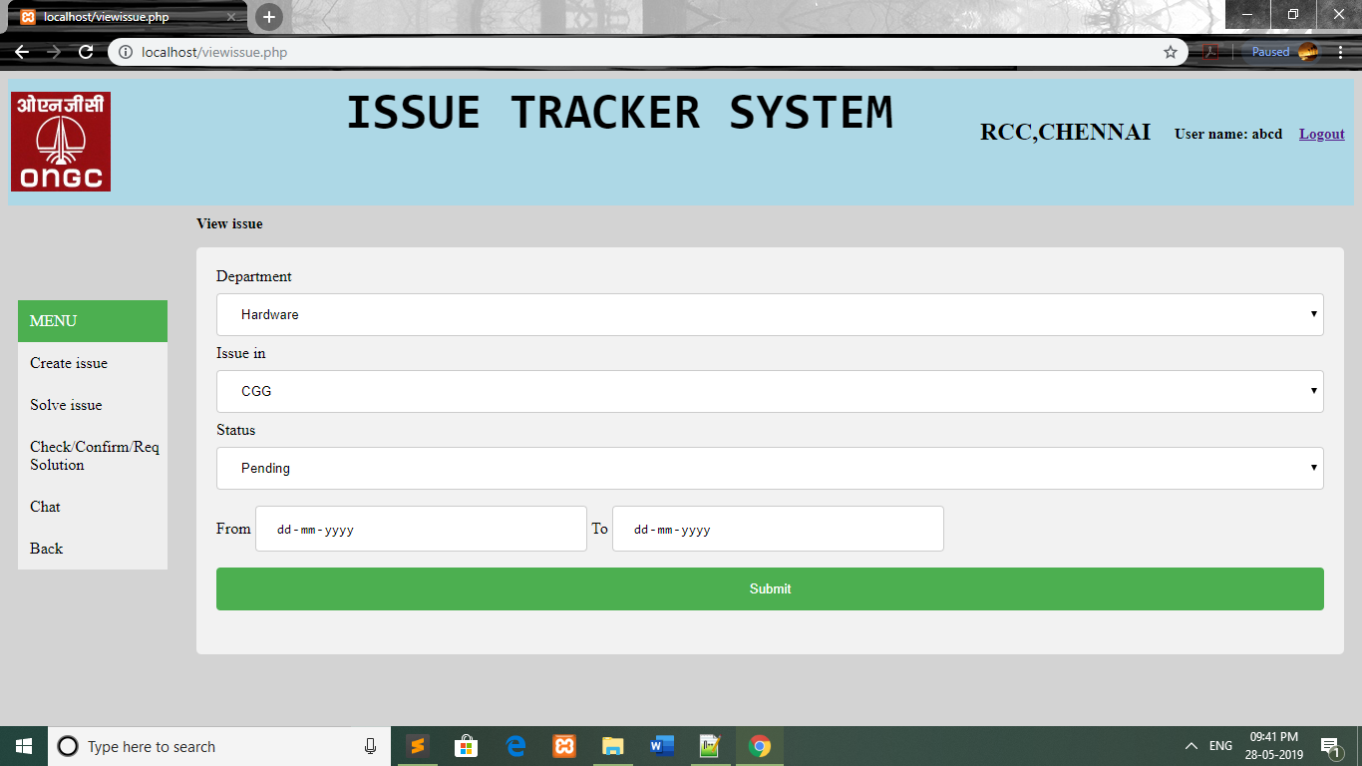

Pagename: viewissue

Fields:Department, Issue in, Status , From , To

Table: issues

Process: To view the issues from a particular department and period.

Error: no

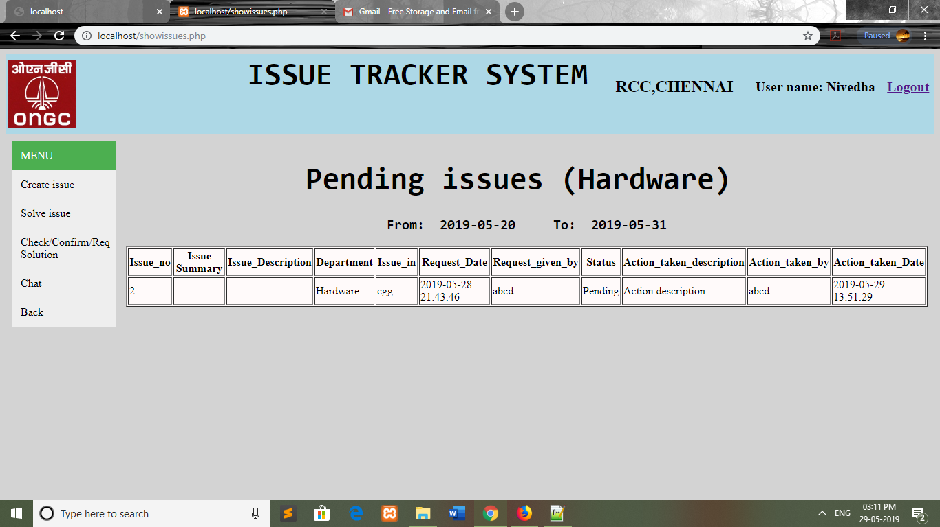

Pagename: showissues

Fields:Cpf_No,From date,To date,Status

Table:issues

Process: Displays the details of the issues for the requested particulars and no modification can be done in this page.

Error: no

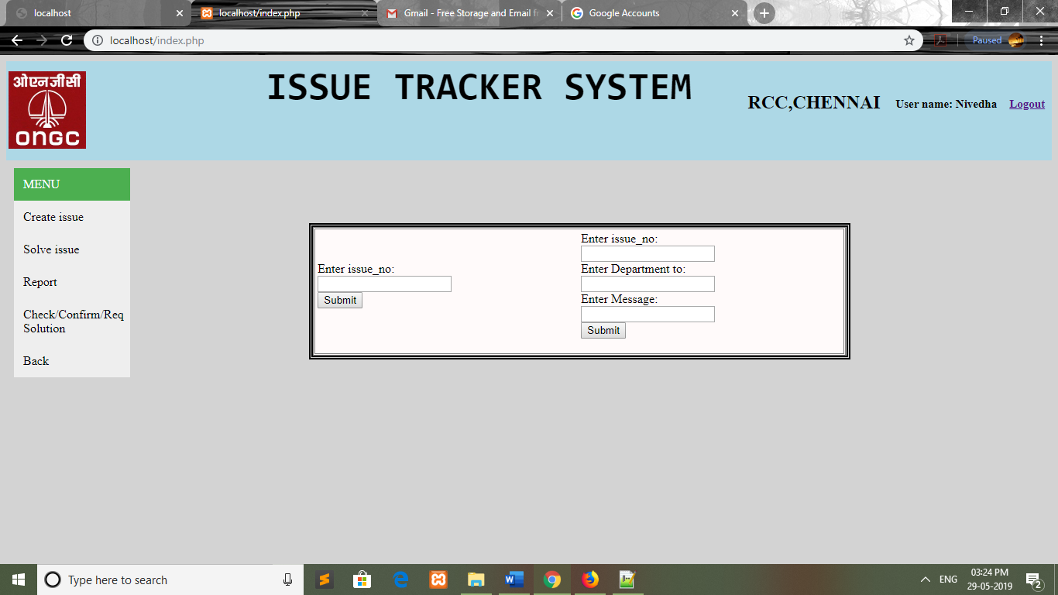

Pagename:index

Fields:Issue_ID, Department_No, Message

Table: chat

Process: To suggest solutions and view solutions for the issues to a particular department which on further stores it to the table of solutions and display it.

Error: no

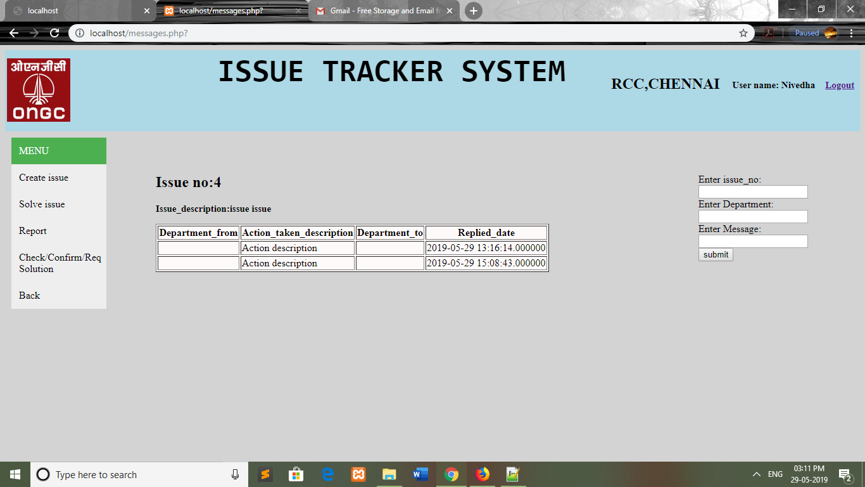

Pagename:messages

Fields:Issue_ID, Department_No, Message

Table: chat

Process: To suggest solutions and view solutions for the issues to a particular department which on further stores it to the table of solutions and display it.

Error: no

**USER INTERFACE DESIGN:**

Every user interface- whether it is designed for a Web App or a traditional software application- should exhibit the following characteristics:

* Easy to use.
* Easy to learn.
* Easy to navigate.
* Intuitive.
* Consistent.
* Efficient.
* Error-free.
* Functional.

It should provide the end-user with a satisfying and rewarding experience. Our web application follows all these principle of effective user interface design. Like an effective interface, it is visually apparent and forgiving, instilling in its users a sense of control. Users quickly see the breadth of their options, grasp how to achieve their goals, and do their work. It does not concern the user with the inner workings of the system and the users have the full option to undo activities at any time.

Like effective applications and services, it performs a maximum of work, while requiring a minimum of information from the users.

**WEB APPLICATION**

Web application (Web App) testing is a collection of related activities with a single goal: to uncover errors in Web App content, function, usability, navigability, performance, capacity, and security. To accomplish this, a testing strategy that encompasses both reviews and executable testing is applied throughout the Web engineering process. If end users encounter errors that shake their faith in the Web App, they will go elsewhere for the content and function they need, and the Web App will fail. For this reason as many errors as possible must be eliminated before the Web App goes online.

**CONCLUSION**

In review this internship has been an excellent and rewarding experience. I have been able to meet and network with so many people that I am sure will be able to help me with opportunities in the future.

Throughout my internship, I could understand more about the setup and infrastructure established in major public sectors like ONGC and this gives me to opportunity to understand the definition of an IT engineer and think myself to become a responsible and innovative IT professional in future.

**Thank you**